PURPOSE
The main purpose of Botswana Jobs Connect is to centralize job opportunities in Botswana into one accessible digital platform, making it easier for job seekers to discover, access, and apply for employment opportunities.
TARGET AUDIENCE
~Age ( 18-65 )
~Location ( locally)
~Employment Status ( Unemployed, internships or attachments seekers )
TECHNICAL APTITUDE
~Moderate digital literacy
~Comfortable using basic web browsing
~Familiar with E-mail and Online forms
TYPE OF WEBSITE
The system is a job information website that collects and shows job opportunities in one place. It helps users easily find jobs using descriptions and filters. The design is simple, user-friendly, and made for people with different levels of tech literacy.
INFOMATION DESIGN & TAXANOMY
The system will use a simple and clear layout to help users find job information quickly. Each page will have a consistent structure, including a navigation bar at the top, main content in the center, and a footer at the bottom.
The structure follows a hierarchical layout, starting from the Home Page and branching into key sections.
~Home
~About Us
~Jobs
~CVs & Candidates
~Post a Job
~Contact us
USER NAVIGATION FLOW
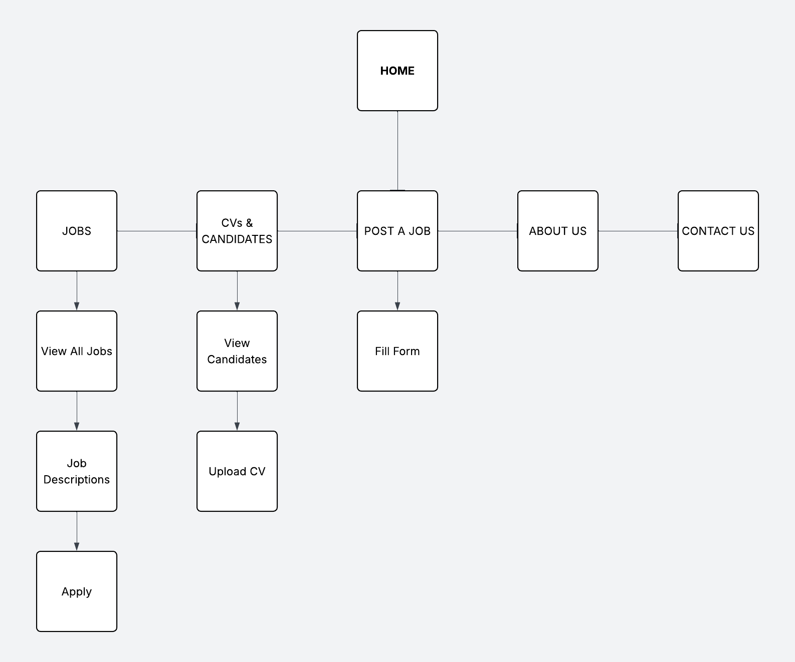
PAGE TEMPLATE DESIGN
HOME PAGE
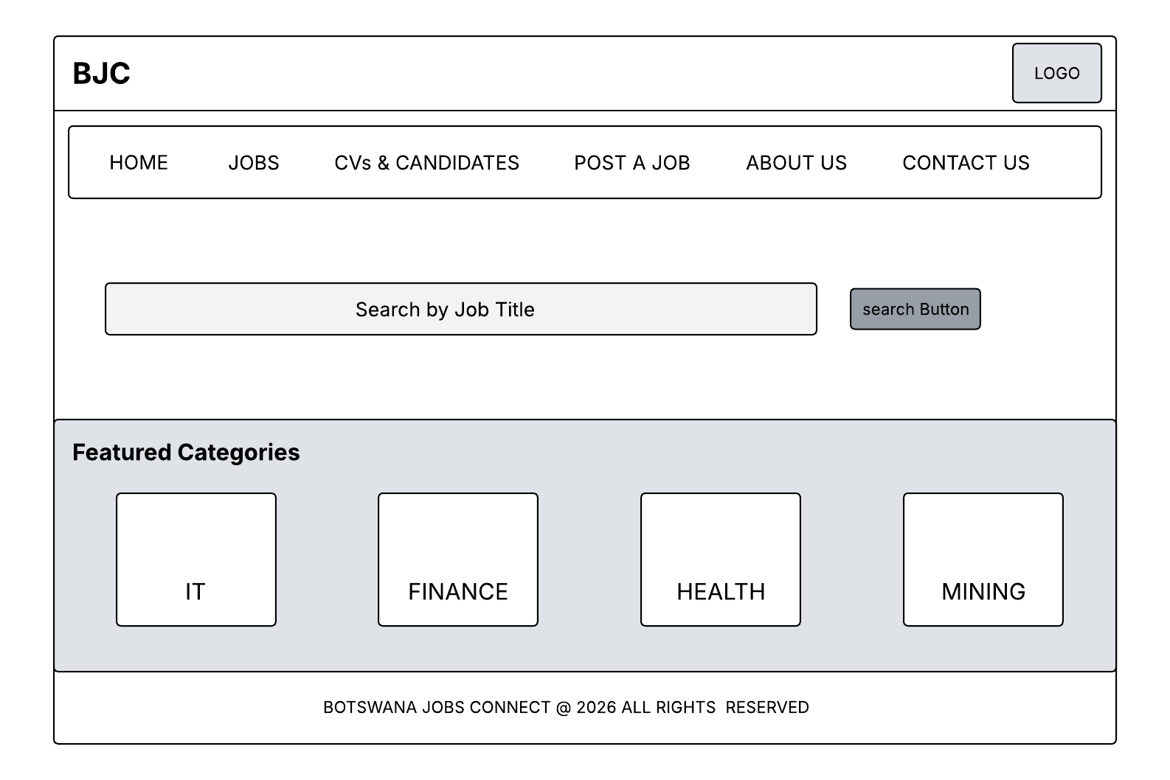
JOBS PAGE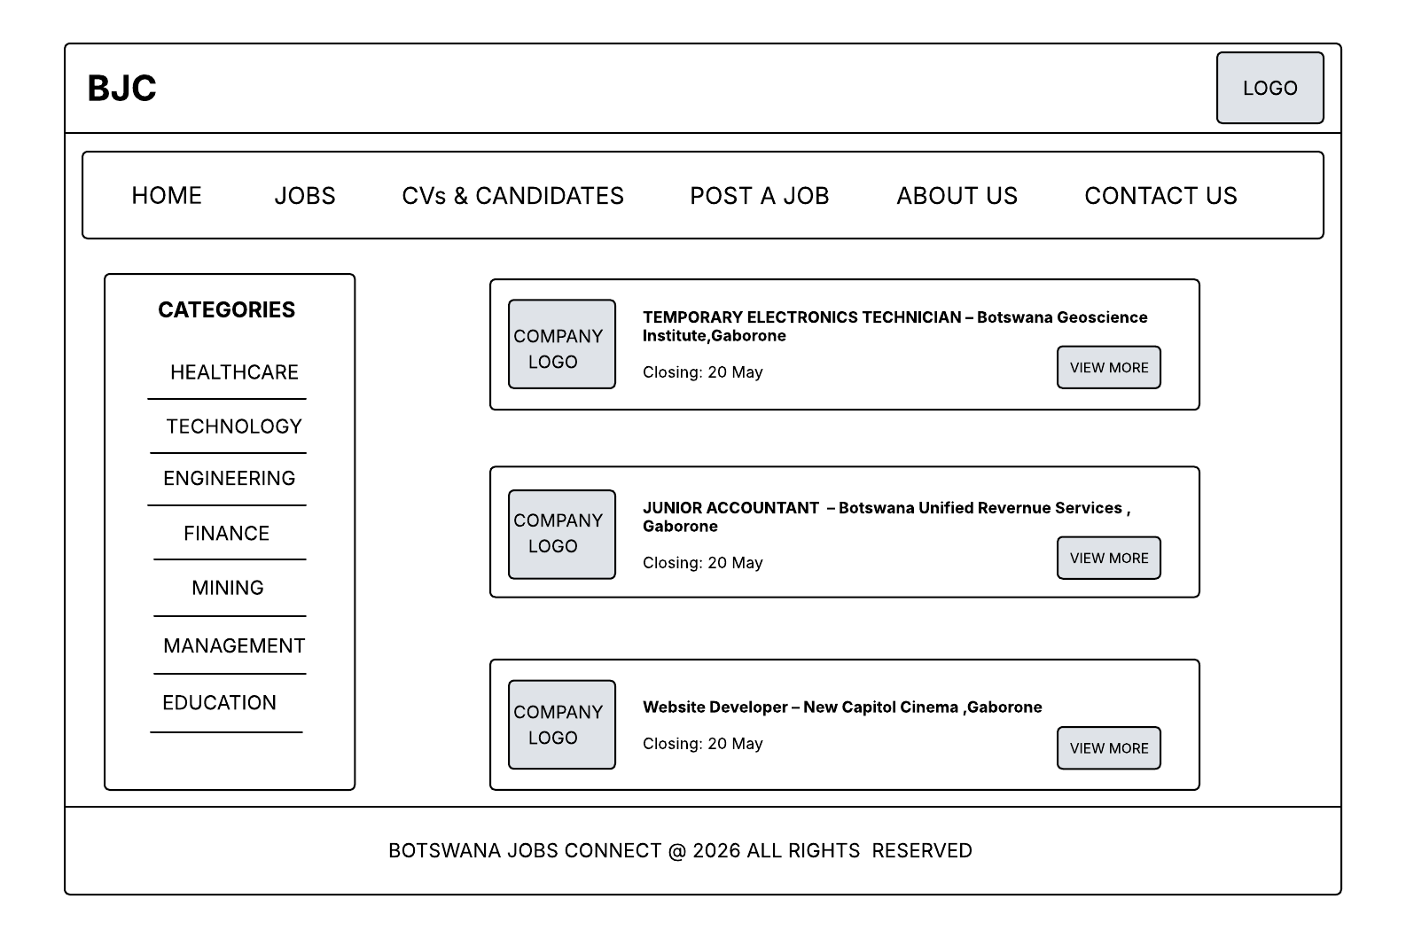
CVs & CANDIDATES PAGE
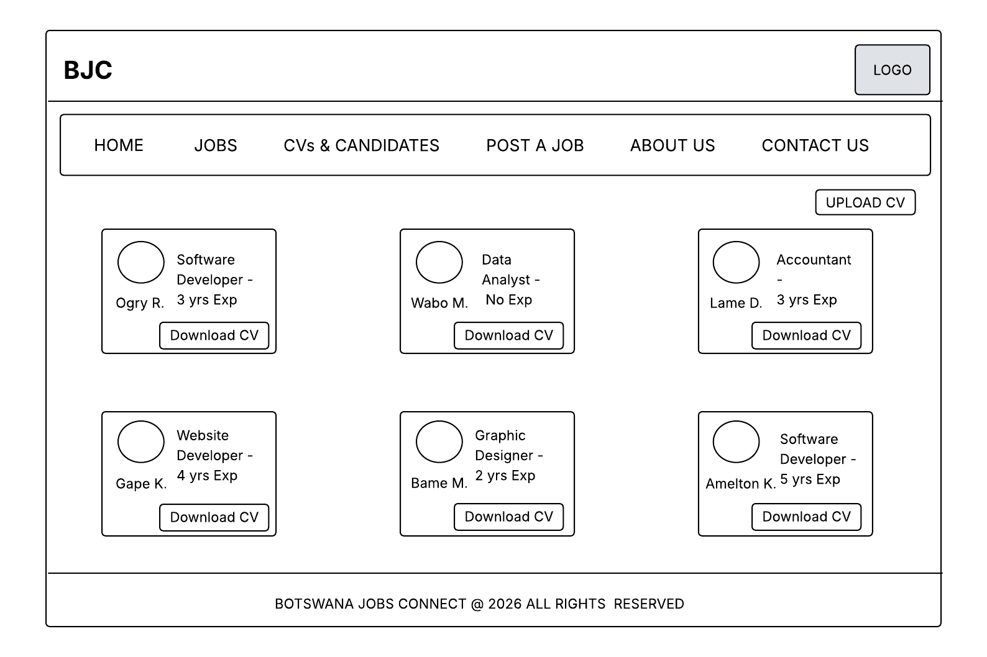
POST A JOB
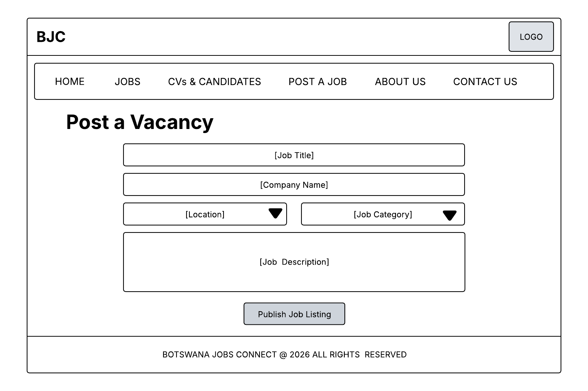
ABOUT US PAGE
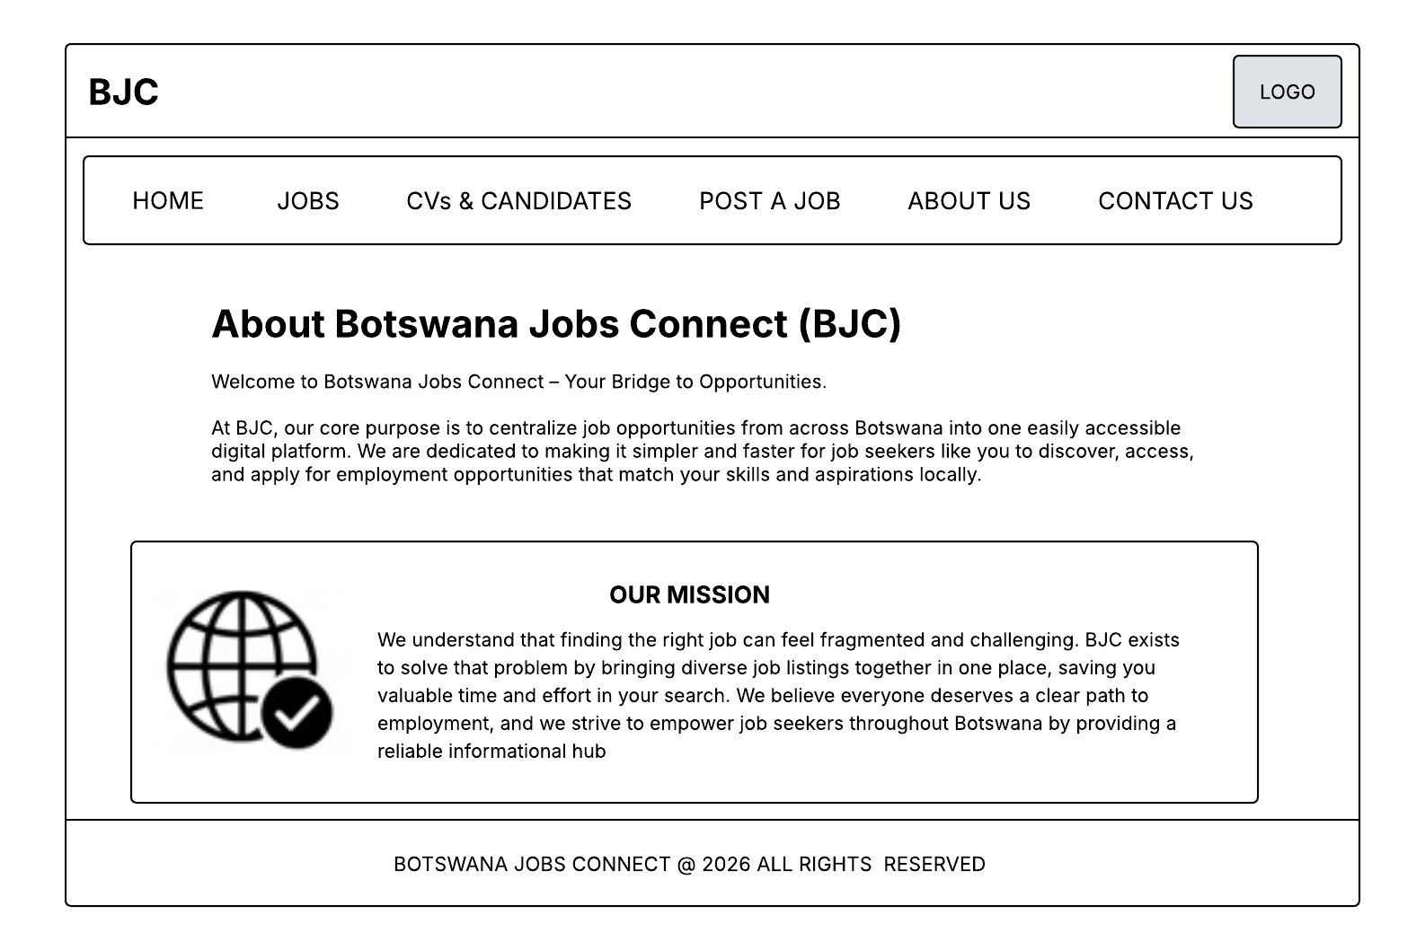
CONTACT US PAGE
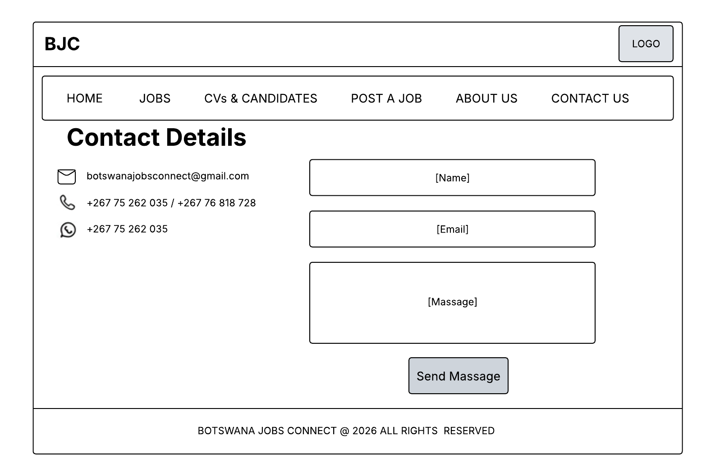
JOB DETAILS VIEW PAGE
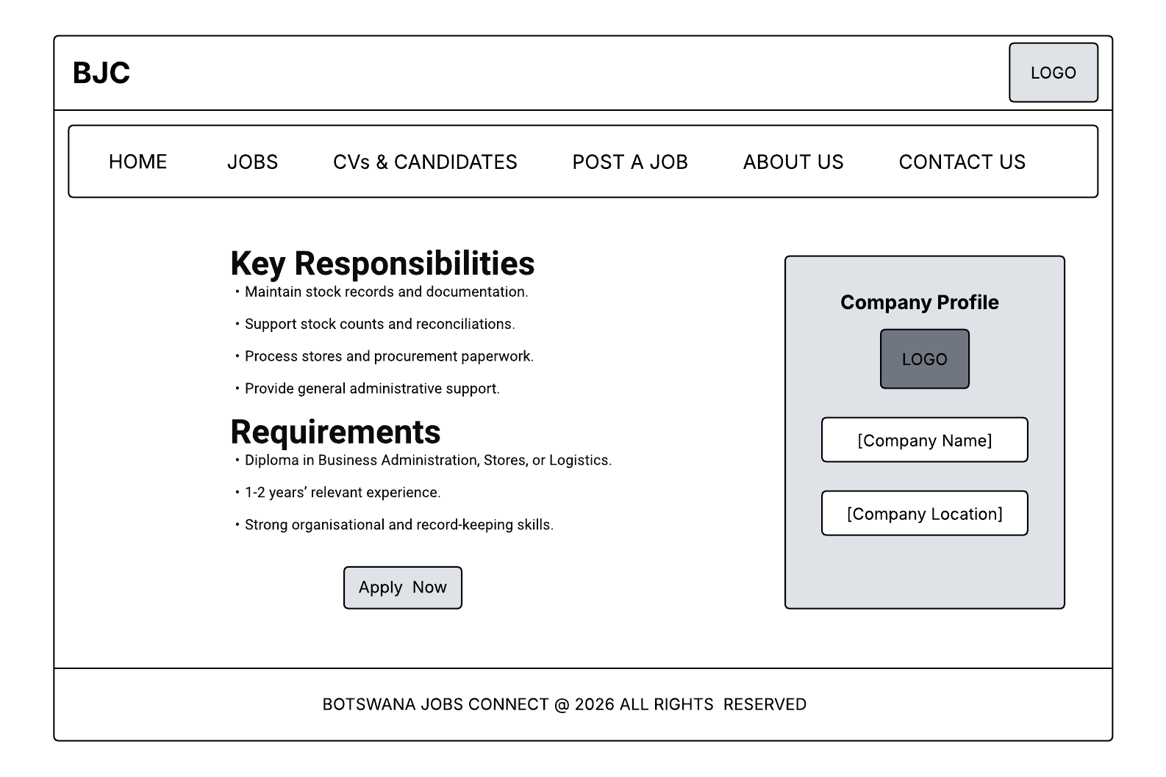
TECHNICAL BREIF
The proposed system will be developed as a web-based application that helps users find and search for job opportunities online. The system will be simple, efficient, and easy to use.
The front-end will be built using HTML and CSS. HTML will create the structure of the web pages, CSS will be used for the design and layout.
JavaScript is used to simulate backend functionality by storing job data in arrays and displaying it on the webpage. It also allows users to search and filter jobs without needing a real server or database.
A database will be used to store important information like job details and company information.
The website will be hosted online using platforms like GitHub Pages for testing deployment.
The system will be responsive, meaning it will work well on phones, tablets, and computers. This is important because many users will access the website using mobile devices

